6.103: a) The walk will take one-fifth of an hour, 12 min. From the graph, the oxygen consumption rate appears to be about 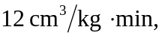 and so the total energy is

b) The run will take 6 min. Using an estimation of the rate from the graph of about 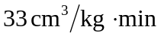 gives an energy consumption of about 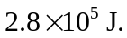 c) The run takes 4 min, and with an estimated rate of about 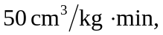 the energy used is about d) Walking is the most efficient way to go. In general, the point where the slope of the line from the origin to the point on the graph is the smallest is the most efficient speed; about 5 